Installation procedure for HIL:  
  
Prerequisites: Github account and forked the HIL repository:

Install the dependencies:

yum install epel-release bridge-utils gcc httpd ipmitool libvirt \

libxml2-devel libxslt-devel mod_wsgi net-tools python-pip python-psycopg2 \

python-virtinst python-virtualenv qemu-kvm telnet vconfig virt-install

Clone repo:

git clone https://github.com/**username**/hil.git

cd hil

( Go to the repository and the fork place, the in the clone or download part- if we click, a link will come, copy paste that link.. it ends with a hil.git)

Creating a virtual environment for Python:

virtualenv .venv

source .venv/bin/activate

easy_install -U setuptools

pip3 install --upgrade setuptools

pip install -e .[tests]

Configure HIL:

cp examples/hil.cfg.dev-no-hardware hil.cfg

Initialize database:

hil-admin db create

Start server:

hil serve 5000 a( this a is used for running the server in the background)

From a separate terminal window: (Can do it in the same terminal itself)

cd ~/hil/

virtualenv .venv

source .venv/bin/activate

pip install -e .

Make sure the server is running in the background by using this method:

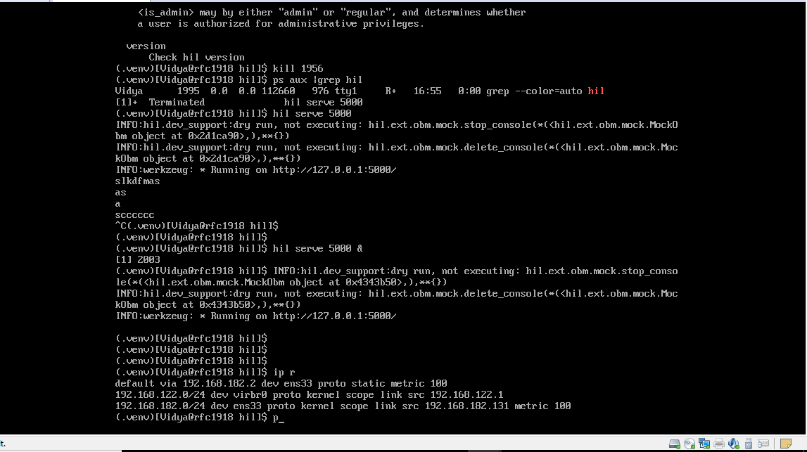

Testing the setup:

hil list_nodes all

If the above command reports an empty list. HIL is successfully installed and ready for hacking.